**JOBSHEET 5**

**Selection Part 1**



**Name**

Sherly Lutfi Azkiah Sulistyawati

**NIM**

2341720241

**Class**

1I

**Department**

Information Technology

**Study Program**

D4 Informatics Engineering

Labs Activity

**Question! (Experiment 1)**

1. Modify the above selection statement (if-else) by using Ternary Operator! We know that Ternary Operator could be used as a selection statement as well.
2. Compile, run and observe the result!
3. Commit and push the changes into your repository!
4. Finally, please explain why the output of the program before and after the changes has a similar output.

**Answer!**

1. 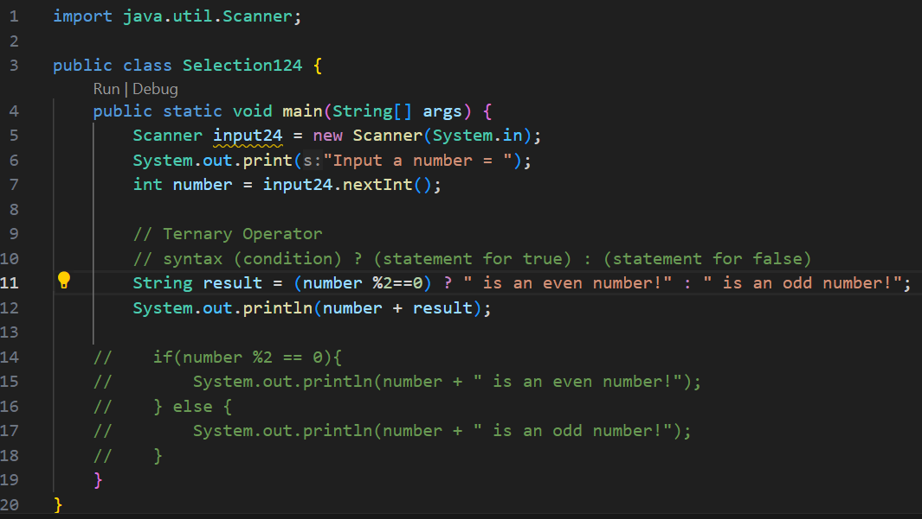
2. The similarity in output is because both approaches (if-else and ternary operator) are functionally equivalent, they just represent different ways of achieving the same logic.

**Question! (Experiment 2)**

1. Modify the above program so that it now can convert from numerical grade into letter grade, based on the following rule! Commit and push the changes into your repository!
2. After the above modification, how many conditions are there and what type of operator are used?

**Answer!**

1. 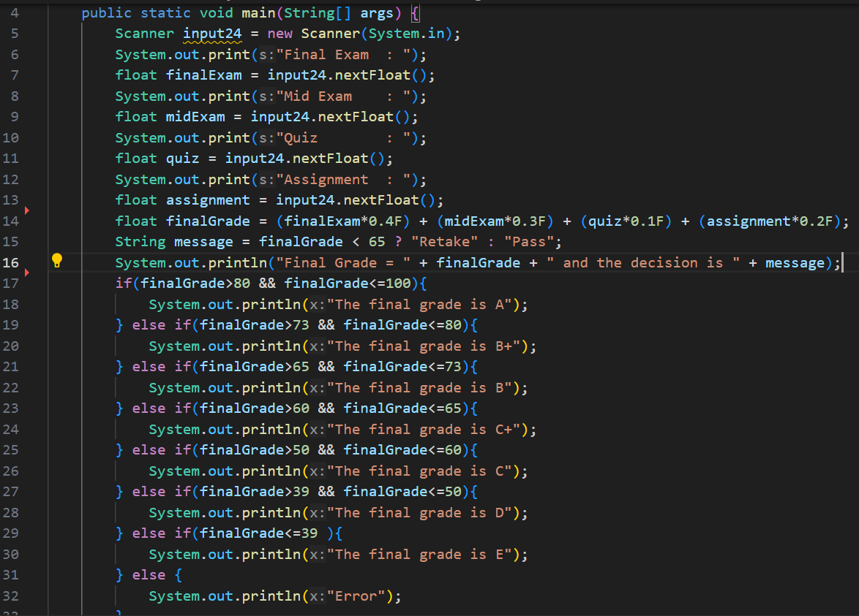
2. There are 8 conditions with a combination of the ternary conditional operator and if-else statements to evaluate different aspects of the final grade calculation and grading.

**Question! (Experiment 3)**

1. What is the use of break and default statement?
2. Modify the above program by deleting break statement in the first case. Run the program, observe the result, and explain what it is the effect if there is no break in case block!
3. Commit and push the changes into your repository.
4. Please explain the function of the following statement

operator = sc.next().charAt(0);

**Answer!**

1. The break statement is used to control the flow within a switch statement, while the default case provides a default action to be taken when none of the specified case values matches the expression.
2. If deleting the break statement in the first case block of the switch statement, the program will exhibit a behavior known as "fall-through." This means that after the code in the first case block is executed, the program will continue to execute the code in subsequent case blocks until it encounters a break statement or reaches the end of the switch statement.
3. The statement is used to read a character input from the user using a Scanner object (sc) and then assign the first character of the input string to the variable operator.

**Assignment**

**Time: 160 minutes**

Create a program based on the flowchart that was already created in Assignment 5 in the Slide of Selection part 1! Commit and push the code results to your project repository!

**Note:** The assignment may only apply the material covered from Week 1 to Week 5.

**Answer!**

